**Necessary materials and tools:**

1. Sliced bread, 2 slices. (Any kind of sandwich bread can be used, white or whole wheat. This guide uses pre-sliced whole wheat bread for our example.)
2. Peanut butter, approximately 1 tablespoon. (Use creamy peanut butter for easier spreading. However, crunchy peanut butter can be used if desired. This guide uses creamy peanut butter.)
3. Jam, approximately 1 tablespoon. (This guide uses strawberry jam for demonstration. But other flavors, such as grape or raspberry, are also viable alternative options.)
4. A table knife. (This guide uses a metal table knife, but a plastic knife can be used if there are any safety concerns. Optionally, have two or three knives on hand to avoid having to clean the knife between steps. If a knife is not available, a spoon or fork can be used instead.)
5. A Plate. (It should be one that is large enough to hold two slices of bread side by side.)

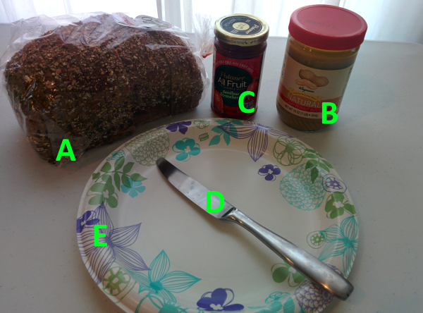

**Assembly instructions:**

1. Open the bag of bread, take out two slices, and place them side by side on the plate. If possible, it is ideal to select slices from close to the middle of the loaf for size consistency.

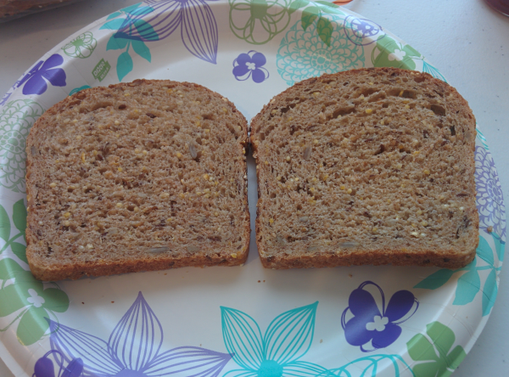

1. Open the jar of peanut butter, scoop up some peanut butter with the knife, and place that onto one of the bread slices on the plate. The scooping process can be repeated until there is about 1 tablespoon of peanut butter on that slice of bread. The amount is approximate and does not need to be exact. Be careful to keep your hand steady and have the plate with the bread slices close to the peanut butter jar before scooping to minimize risks of accidents. (Tip: This step can be performed with a spoon or fork if a knife is not available.)

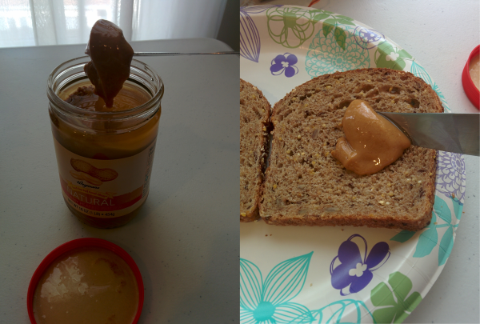

1. With the knife, spread the scooped out peanut butter on the slice of bread into an even, thin layer to cover that side of the bread slice completely. A bit more peanut butter can be added from the jar during this process if desired. However, be careful not to add too much to avoid overloading and causing the final assembled product to be messy and runny. (Tip: This step can be performed with a spoon or fork if a knife is not available.)

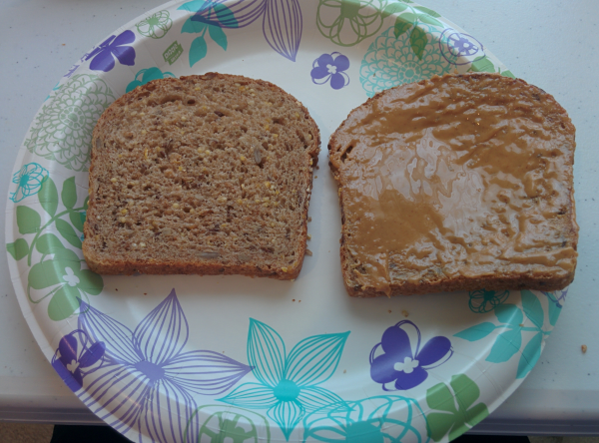

1. Clean the knife used in the previous step by rinsing off the residue with water. Alternatively, put the used knife in a safe location, such as the kitchen sink, for cleaning later and use a new clean knife for the next step.
2. Open the jar of jam, scoop up some jam with the knife, and place that onto the other slice of bread on the plate (the slice without peanut butter). The scooping process can be repeated until there is about 1 tablespoon of jam on that slice of bread. The amount is approximate and does not need to be exact. Be careful to keep your hand steady and have the plate with the bread slices close to the jam jar before scooping to minimize risks of accidents. (Tip: This step can be performed with a spoon or fork if a knife is not available.)

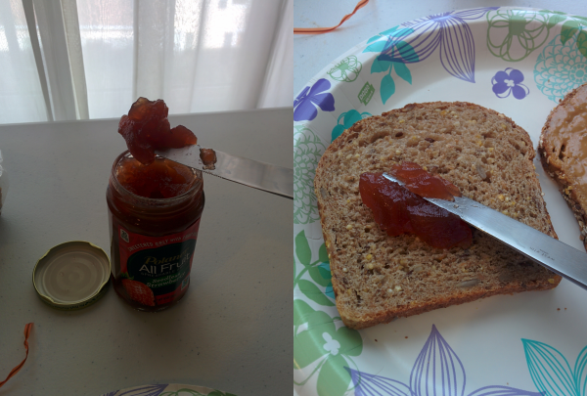

1. With the knife, spread the scooped out jam on the slice of bread into an even, thin layer to cover that side of the bread slice completely. A bit more jam can be added from the jar during this process if desired. However, be careful not to add too much to avoid overloading and causing the final assembled product to be messy and runny. (Tip: This step can be performed with a spoon or fork if a knife is not available.)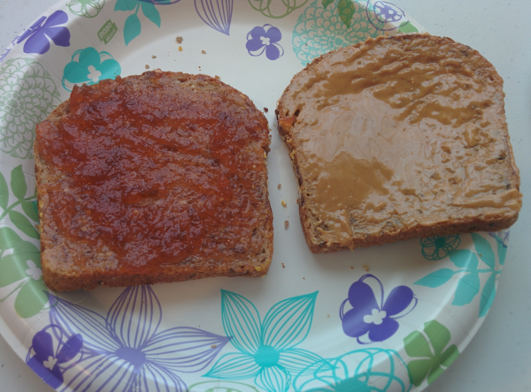
2. Once done with the previous step, put the knife aside on the edge of the plate or somewhere safe.
3. Pick up the slice of bread with jam on top by the edges and place it on top of the other slice on the plate by turning the slice in your hand over so that the jam side faces the peanut butter side of the other slice as you line up the edges of the two slices and place them together.

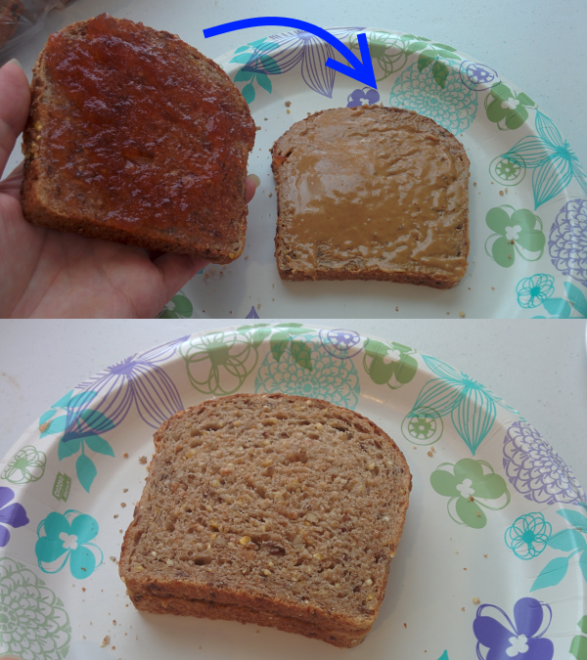

1. Optional step: Rinse the knife used to spread jam off with water or use a clean knife. With the knife, slice the assembled sandwich down the middle, vertically or diagonally, to cut into 2 approximately equal sized pieces for easier consumption. The example shown below is of the sandwich cut into two parts vertically along the center.

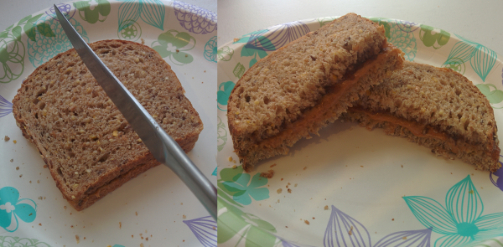

1. Final step: Tidy up the work area. Close the bread bag, the peanut butter jar, and the jam jar. Wash the knife or other utensils used in the previous steps of the guide or put them in a safe location for cleaning later. Wipe away crumbs and/or smudges from your work surface, if there are any.

Total word count: 812